**TASK 2**

**ECE 2006**

**DIGITAL SIGNAL PROCESSING LAB**

YASHAWANT BASU

15BEC0389

Study and Analysis of ECG Signal

**Objective:**

To study and analyse the given ECG signal (R-R interval) using Signal Processing Tool and determine the average R-R interval in given ECG signal using MATLAB

**Introduction:**

Electrocardiogram (ECG) is the transthoracic interpretation of the electrical activity of the heart over a period of time. Analysis of ECG signal provides information regarding the condition of heart. Various methods like Fast Fourier Transforms, Wavelet Transform, etc. have been used for detection of cardiac diseases.

Each heart beat displayed is a sequence of electrical waves characterized by peaks and valleys. ECG mainly provides two kinds of information. One is the duration of the electrical wave passing through the heart and it will decide whether the electrical activity is normal or slow or irregular. Second is the amount of electrical activity passing through the heart muscle that helps to find whether the parts of the heart are too large or overworked. The frequency range of an ECG signal is 0.05– 100 Hz and its dynamic range is 1–10 mV. The ECG signal is characterized by five peaks and valleys represented by the letters P, Q, R, S, T. Sometimes U wave is also present. The performance of ECG analysis is based on the accurate and reliable detection of the QRS complex as well as T- and P waves.The P-wave represent the activation of the two atria, the upper chambers of the heart, while the QRS complex and T-wave represent the excitation of the lower chamber of the heart, the ventricles. QRS detection is one of the fundamental issues in automatic ECG signal analysis. After QRS complex has been detected a thorough examination of ECG signal is done. The QRS complex gives the combined result of the repolarization of the atria and depolarization of the ventricles, which occurs almost at same time. The usual rate of heart is 60 to 100 beats per minute. A slower rate than the normal range is called bradycardia (slow heart) and a higher rate is called tachycardia (fast heart). If the ECG signal is not normal then an Arrhythmia is indicated.

The RR interval is the time measurement between the [R wave](https://www.cardionetics.com/ecg-waveforms#rwave) of one heartbeat and the [R wave](https://www.cardionetics.com/ecg-waveforms#rwave) of the preceding heartbeat.

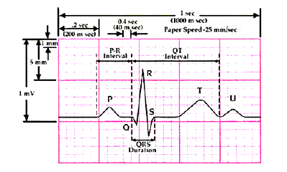

A typical ECG signal

The methods used for diagnosis generally involve four essential processes to arrive at the accurate and quick decisions about the kind of heart disease a patient suffers from. It includes:

1. Data Acquisition

2. De-noising

3. Feature Extraction

4. Classification.

Motive of this task is to analyze a given ECG signal and to determine whether the given ECG signal is of a healthy person. Signal processing tool is used to design a filter that can de-noise any ECG signal and help in analyzing the ECG signal. Filter is designed for 360 samples at a time. The original is taken and multiplied with a signal having high frequency and same is done with signal having low frequency. This produces two noisy ECG signals, after this they are added and a net noisy ECG signal is produced. This signal is passed through the filter designed using signal processing tool box and hence, we get back the original de-noised ECG signal. The data is exported to the workspace and then plotted so as to realize the working of the filter. Then, heart rate of the given ECG is calculated and checked whether it is normal or abnormal. Peak to peak, i.e., individually R-R distance is calculated and after this average distance is calculated.

**MATLAB Code:**

clc;

clear all;

close all;

load('100m.mat');% extracting data from the respective ECG data file

x2=val(1,:);

x2=(x2-1024)/200;

subplot(2,2,1);

title('ECG Signal');

plot(x2); % Plotting original ECG Signal

title('ECG Signal');

sampling_frequency=360;

mains_coeff=0.1;

time_step=1/sampling_frequency;

max_time=10;

t=time_step:time_step:max_time;

mains_signal=cos(2*pi*60*t);

dirty_signal=x2+mains_coeff*mains_signal; %High frquency Noise ECG Signal

subplot(2,2,2);

plot(dirty_signal);% Plotting High frquency Noise ECG Signal

title('Dirty Signal');

mains_signal_1=cos(2*pi*0.1*t);

dirty_signal_1=x2+mains_coeff*mains_signal_1;%Low frquency ECG Noise Signal

subplot(2,2,3);

plot(dirty_signal_1);

title('Dirty Signal_1');% Plotting Low frquency Noise ECG Signal

signal_freq=dirty_signal+dirty_signal_1;%Adding both high and low frequency

subplot(2,2,4);

plot(signal_freq);%Plotting the Noisy ECG signal

title('Signal with Noise');

j=1;

for i=2:length(x2)-1

if(x2(i)>x2(i-1) & x2(i)>x2(i+1) & x2(i)>0.5)

k(j)=i;

k1(j)=x2(i);

j=j+1;

end

end

j=j-1;

sprintf('Heart rate is')

length(k)*6 % Calculating the heart rate from the signal

figure(2);

plot(x2)

hold on

sprintf('R peak distance in seconds')

plot(k,k1,'ro'); %plotting the peaks in the signal

title('Peaks of the signal');

kdis=diff(k)% Calculating R-R peak distance

sprintf('Average R-R interval')

pk=sum(kdis)/(length(k)-1) % Average peak to peak distance

% Checking whether heart rate is normal or abnormal

if (length(k)*6>150)

sprintf('Abnormal Heart Rate')

elseif (length(k)*6<60)

sprintf('Abnormal Heart Rate')

else

sprintf('Normal Heart Rate')

end

**OUTPUT:**

For 100m.mat signal

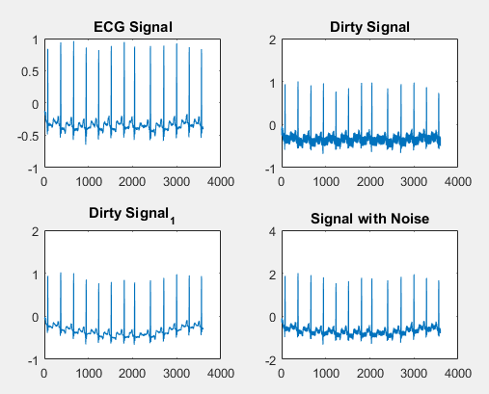

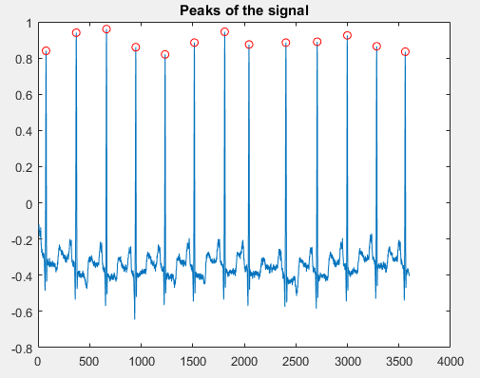

Heart rate is

78

R peak distance in seconds

293 293 284 284 284 294 236 358 303 292 285 277

Average R-R interval

290.2500

Normal Heart Rate

For 124m.mat signal

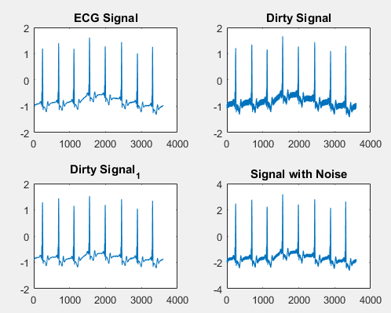

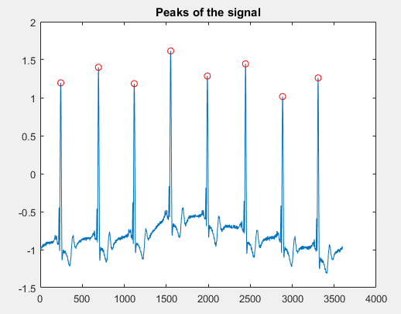

Heart rate is

48

R peak distance in seconds

449 426 434 436 455 441 423

Average R-R interval

437.7143

Abnormal Heart Rate (Bradycardia)

For 200m.mat signal

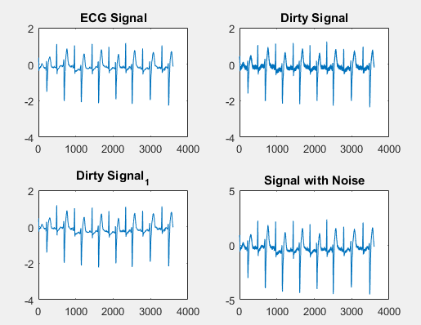

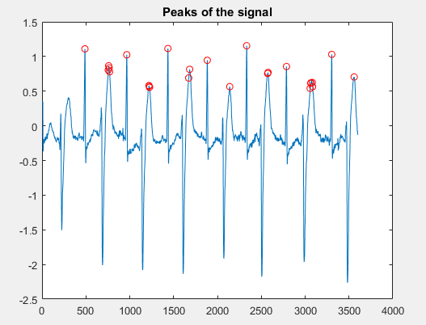

Heart rate is

156

R peak distance in seconds

Columns 1 through 20

266 5 5 5 196 253 2 4 2 208 237 11 201 256 193 239 5 210 270 6

Columns 21 through 25

2 16 4 218 256

Average R-R interval

122.8000

Abnormal Heart Rate (Tachycardia)

**Result:**

The first signal 100m belongs to a patient having normal heart rate

The second signal 124m belongs to a patient having slow heart rate (Bradycardia)

The third signal 200m belongs to a patient having high heart rate (Tachycardia)

**Conclusion:**

Thus the analysis of ECG signals was successfully completed using MATLAB for different types of heart rates.